**TOPOLOGY OF ELECTRICAL SYSTEMS**

# Objective

* **Maximum reliability** for vital systems
* Dashboard and monitoring reduced to **the necessary**

# Composition of the harness

* **DTA S80 ECU**
* **Gear control box**, composed of an Arduino Mega and a custom shield sealed in a Polycarbonate box aimed to control the brushless servomotor
* **Dashboard control box**, composed of an Arduino Mega sealed in an ABS box, aimed to transmit data between the CAN Bus and the dashboard
* **Carbon dashboard**, embeds all the necessary lights and buttons and minimizes the electronic elements sensitive to outdoor conditions.
* Littlefuse sealed **hard-wired power distribution module**, composed of simple relays and fuses
* Lightweight and compact SuperB **LiFePO4 battery**

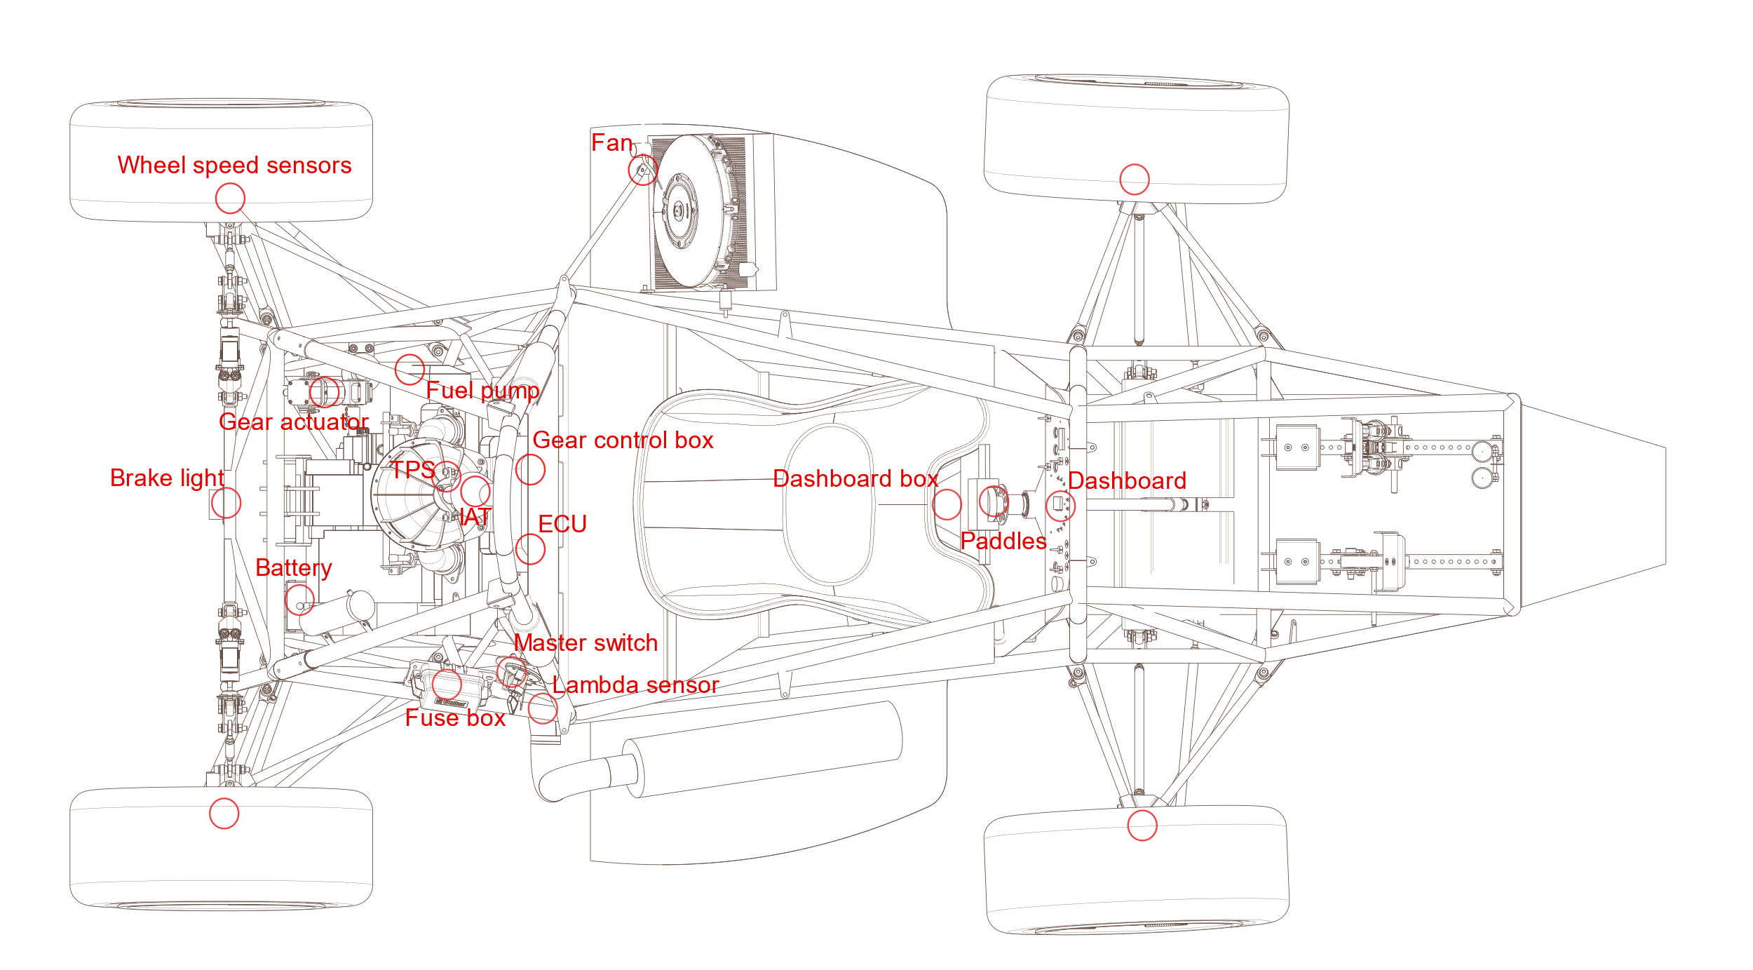

Figure 1: Position of electrical systems in the car

Vital systems are hard-wired in the harness whereas secondary data is transmitted through a CAN bus.

# Data management

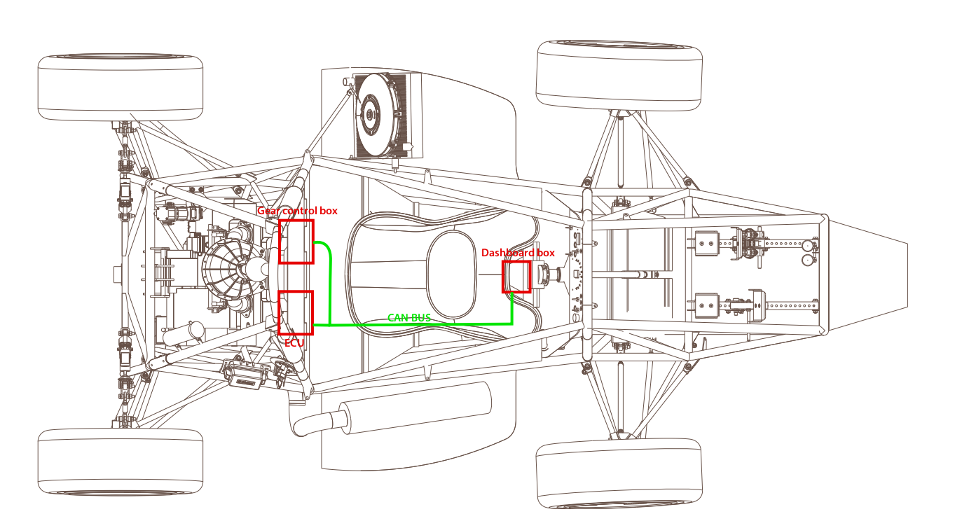A **CAN BUS** is aimed to exchange data between the ECU, the gear control box, and the dashboard box.

Figure 2: CAN bus implementation in the car

## Emission ⇧ and reception ⇩ through CAN

|  |  |  |
| --- | --- | --- |
| **ECU** | **Dashboard box** | **Gear control box** |
| ⇧ Water temperature  ⇧ RPM  ⇧ Oil pressure | ⇧ Neutral button ⇧ Servomotor homing button ⇩Water temperature  ⇩ RPM  ⇩ Oil pressure  ⇩ Engaged gear | ⇩ Neutral button ⇩Servomotor homing button    ⇧ Engaged gear |

## Hard-Wired data

* Gear shift
* Traction control, launch control, log switch and injection map selection buttons
* Shift light
* Engine start
* Fan control
* Neutral light

## 

Figure 3: Dashboard composition

# ECU choice

Figure 4: Comparison of different ECU available

## DTA S80 pro

* Sequential fuel and ignition with 3D maps
* Correction with air and water temperature, throttle transients
* Fuel starting map
* Compatible with engine and genuine sensors
* Idle control
* Simple software
* Lambda sensor input
* Data logging up to 100Hz
* Shiftcut, launch and traction control